**DAILY ONLINE ACTIVITIES SUMMARY**

|  |  |  |  |  |  |  |  |  |
| --- | --- | --- | --- | --- | --- | --- | --- | --- |
| **Date:** | **06/06/2020** | | | | | **Name:** | **Shwetha** | |
| **Sem & Sec** | **8th B** | | | | | **USN:** | **4AL16CS101** | |
| **Online Test Summary** | | | | | | | | |
| **Subject** | | **IOT** | | | | | | |
| **Max. Marks** | | **30** | | **Score** | | | **30** | |
| **Certification Course Summary** | | | | | | | | |
| **Course** | **Introduction to cyber security** | | | | | | | |
| **Certificate Provider** | | | **Great learning** | | **Duration** | | | **7hr** |
| **Coding Challenges** | | | | | | | | |
| **Problem Statement:**  **Python program for given a two list. Create a third list by Picking an odd-index element from the first list and even index elements from second.** | | | | | | | | |
| **Status: Solved**  **Solution link: https://github.com/alvas-education-foundation/Shwetha-** | | | | | | | | |
| **Uploaded the report in Github** | | | | | **Yes** | | | |
| **If yes Repository name** | | | | | **Shwetha-** | | | |
| **Uploaded the report in slack** | | | | | **Yes** | | | |

Online Test Details:

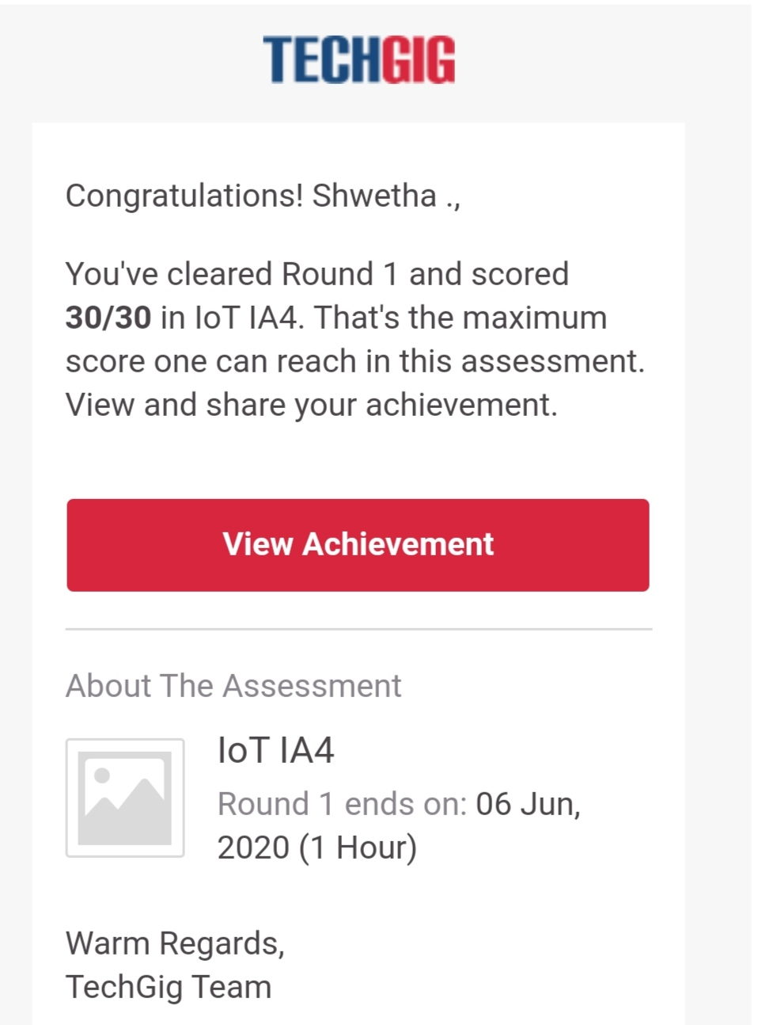

Certification Course Details:

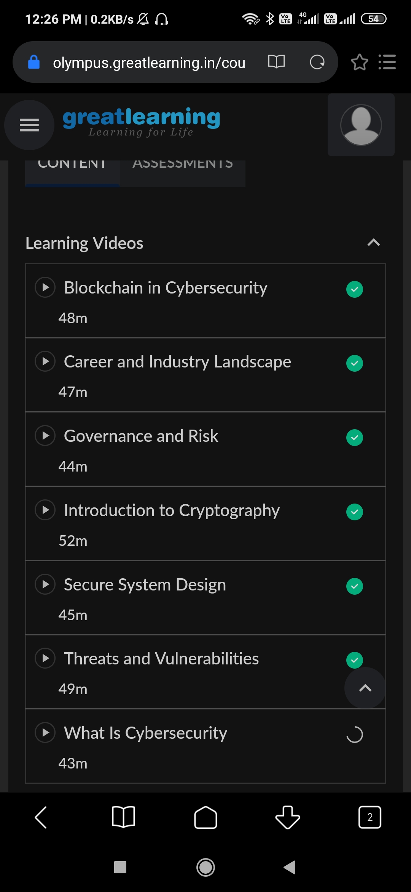

Coding Challenges Details:

listOne = [3, 6, 9, 12, 15, 18, 21]

listTwo = [4, 8, 12, 16, 20, 24, 28]

listThree = list()

oddElements = listOne[1::2]

print("Element at odd-index positions from list one")

print(oddElements)

EvenElement = listTwo[0::2]

print("Element at even-index positions from list two")

print(EvenElement)

print("Printing Final third list")

listThree.extend(oddElements)

listThree.extend(EvenElement)

print(listThree)